|  |
| --- |
| **Day 9 Morning Assignments**  **By**  **Manoj Yekolla**  **03-Feb-2022** |

|  |
| --- |
| **1. Write a C# program to read input from user and print ?**  **a. factorial of a number** |
| Code : |
| using System;  using System.Collections.Generic;  using System.Linq;  using System.Text;  using System.Threading.Tasks;  namespace Day9_Project_1_a_  {  class MathsOperation  {  private int input;  public void ReadInput()  {  Console.WriteLine("Enter a Factorial Number :");  input =Convert.ToInt32(Console.ReadLine());  }  public int Factorial()  {  int fact = 1;  for (int i=1;i<=input;i++)  {  fact = fact * i;    }  return fact;  }  }  internal class Program  {  static void Main(string[] args)  {  MathsOperation mo = new MathsOperation();  mo.ReadInput();  mo.Factorial();  Console.WriteLine(mo.Factorial());  Console.ReadLine();  }  }  } |
| Output :  Screenshot (139) |

|  |
| --- |
| **1 (b). factors of a number ?** |
| Code : |
| using System;  using System.Collections.Generic;  using System.Linq;  using System.Text;  using System.Threading.Tasks;  namespace Day9_Project1_b_  {  class MathOperation  {  private int input;  //Read Factors  public void ReadFactors()  {  Console.WriteLine("Enter a Number :");  input = Convert.ToInt32(Console.ReadLine());  }  public void PrintFactors()  {  for (int i=1;i<=input;i++)  {  if (input % i == 0)  Console.WriteLine(i);  }      }  }  internal class Program  {  static void Main(string[] args)  {  MathOperation obj = new MathOperation();  {  obj.ReadFactors();  obj.PrintFactors();    Console.ReadLine();  }  }  }  } |
| Output :  Screenshot (141) |

|  |
| --- |
| **1(c) check if it prime or not ?** |
| Code : |
| using System;  using System.Collections.Generic;  using System.Linq;  using System.Text;  using System.Threading.Tasks;  namespace Day9_Project1_c_  {  class MathOperation  {  private int input;  public void ReadNumber()  {  Console.WriteLine("Enter a Number :");  input = Convert.ToInt32(Console.ReadLine());  }  public bool IsPrime()  {  int count = 0;  for (int i=1;i<=input;i++)  {    if (input % i == 0)  count++;      }  if (count == 2)  return true;  else  return false;  }  }  internal class Program  {  static void Main(string[] args)  {  MathOperation obj=new MathOperation();  obj.ReadNumber();  if (obj.IsPrime())  Console.WriteLine("input is prime number ");  else  Console.WriteLine("input is not prime number");  Console.ReadLine();    }  }  } |
| Output :  Screenshot (145) |

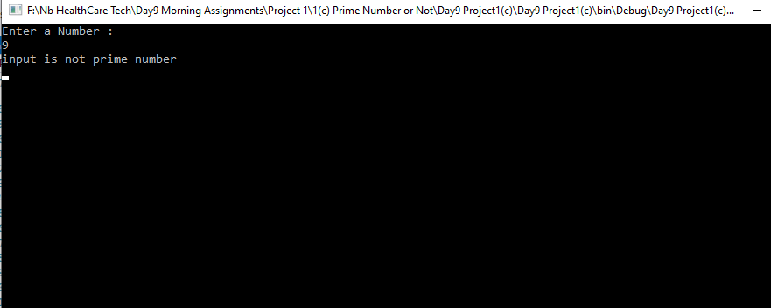

|  |
| --- |
| **2. Write C# program to read two numbers from use and print**  **a. sum of two numbers ?** |
| Code : |
| using System;  using System.Collections.Generic;  using System.Linq;  using System.Text;  using System.Threading.Tasks;  namespace Day9_Project2_a_  {  class MathTask  {  private int a;  private int b;  public void ReadInput()  {  Console.WriteLine("Enter a first number :");  a = Convert.ToInt32(Console.ReadLine());  Console.WriteLine("Enter a second number :");  b = Convert.ToInt32(Console.ReadLine());  }  public int PrintInput()  {  return a + b;  }  }  internal class Program  {  static void Main(string[] args)  {  MathTask obj=new MathTask();  obj.ReadInput();  Console.WriteLine(obj.PrintInput());  Console.ReadLine();  }  }  } |
| Output :  Screenshot (148) |

|  |
| --- |
| **2(b). difference of two numbers ?** |
| Code : |
| using System;  using System.Collections.Generic;  using System.Linq;  using System.Text;  using System.Threading.Tasks;  namespace Day9_Project2_b_  {  class MathTask  {  private int a;  private int b;  public void ReadInput()  {  Console.WriteLine("Enter a first number :");  a = Convert.ToInt32(Console.ReadLine());  Console.WriteLine("Enter a second number :");  b = Convert.ToInt32(Console.ReadLine());  }  public int PrintInput()  {  return a - b;  }  }  internal class Program  {  static void Main(string[] args)  {    MathTask obj = new MathTask();  obj.ReadInput();  Console.WriteLine(obj.PrintInput());  Console.ReadLine();  }  }  } |
| Output :  Screenshot (150) |

|  |
| --- |
| **2(c). product of two numbers ?** |
| Code : |
| using System;  using System.Collections.Generic;  using System.Linq;  using System.Text;  using System.Threading.Tasks;  namespace Day9_Project2_c_  {  class MathTask  {  private int a;  private int b;  public void ReadInput()  {  Console.WriteLine("Enter a first number :");  a = Convert.ToInt32(Console.ReadLine());  Console.WriteLine("Enter a second number :");  b = Convert.ToInt32(Console.ReadLine());  }  public int PrintInput()  {  return a * b;  }  }  internal class Program  {  static void Main(string[] args)  {  MathTask obj = new MathTask();  obj.ReadInput();  Console.WriteLine(obj.PrintInput());  Console.ReadLine();  }  }  } |
| Output :  Screenshot (152) |

|  |
| --- |
| **2(d). division of two numbers.** |
| Code : |
| using System;  using System.Collections.Generic;  using System.Linq;  using System.Text;  using System.Threading.Tasks;  namespace Day9Project2_d_  {  class MathTask  {  private int a;  private int b;  public void ReadInput()  {  Console.WriteLine("Enter a first number :");  a = Convert.ToInt32(Console.ReadLine());  Console.WriteLine("Enter a second number :");  b = Convert.ToInt32(Console.ReadLine());  }  public int PrintInput()  {  return a / b;  }  }  internal class Program  {  static void Main(string[] args)  {  MathTask obj = new MathTask();  obj.ReadInput();  Console.WriteLine(obj.PrintInput());  Console.ReadLine();  }  }  } |
| Output:  Screenshot (154) |

|  |
| --- |
| **3. Create an employee class with below variable . id, name, salary, company**  **write methods to read data and print data.?** |
| Code : |
| using System;  using System.Collections.Generic;  using System.Linq;  using System.Text;  using System.Threading.Tasks;  namespace Day9Project3  {  class Employee  {  public int id;  public string name;  publicS int salary;  public static string company = "NationsBenefits";  public void ReadData()  {  Console.WriteLine("Enter Id Number :");  id = Convert.ToInt32(Console.ReadLine());  Console.WriteLine("Enter Name Number :");  name = Console.ReadLine();  Console.WriteLine("Enter Salary Number :");  salary = Convert.ToInt32(Console.ReadLine());  }  public void PrintData()  {  Console.WriteLine($"id:{id},name:{name},salary:{salary},company:{company}");  }  }  internal class Program  {  static void Main(string[] args)  {  Employee emp = new Employee();  emp.ReadData();  emp.PrintData();  Console.ReadLine();  }  }  } |
| Output :  Screenshot (156) |

|  |
| --- |
| **4. Research and find the difference between normal variable and static variable.** |
| * Static variable does not consume any memory space. * Static variable get intilized immediately Once the execution of the class starts. * Static variable is global variable. * Non-static variable can intilized Only after Creating the object. * Non-static variable is consume memory space. * Non-static variable is like local variable. |

|  |
| --- |
| **5. Write a points discussed about constructor ?** |
| * A constructor is used to intialize class variables while creating an object. * In C-sharp we will have default constructor which we will intialize to default values. * A constructor name same as class name. * In constuctor to use the (this key- word) , when to use this- key word is constructor variable name and class variable name both are confusing that time to use this-keyword. |

|  |
| --- |
| **6. Create Employee class with two constructors as discussed in the class.** |
| Code : |
| using System;  using System.Collections.Generic;  using System.Linq;  using System.Text;  using System.Threading.Tasks;  namespace Day9_Project_6  {  class Employee  {  public int id;  public string name;  public int salary;  public static string company = "NationsBenefits";  public Employee()  {  this.id = 0;  this.name = "null";  this.salary = 0;  }  public Employee(int eid,string ename,int esalary)  {  this.id= eid;  this.name= ename;  this.salary= esalary;  }    public void PrintData()  {  Console.WriteLine($"id:{id},name:{name},salary:{salary},company:{company}");  }  }  internal class Program  {  static void Main(string[] args)  {  Employee emp1 = new Employee();  Employee emp2 = new Employee(1,"manojy",12000);  emp1.PrintData();  emp2.PrintData();  Console.ReadLine();  }  }  } |
| Output :  Screenshot (158) |